 | 12.1.52 Editors - Geometry Nodes Editor - Header - Add Menu - Utilities - Deprecated
Table of content
Detailed table of content 1
Add menu - Deprecated 2
Align Euler to Vector (Deprecated) 2
Rotate Euler (Deprecated) 3

Detailed table of content
Detailed table of content
Detailed table of content 1
Add menu - Deprecated 2
Align Euler to Vector (Deprecated) 2
Inputs 2
Rotation 2
Factor 2
Vector 2
Properties 2
Align Axis 2
Pivot 2
Output 3
Rotation 3
Rotate Euler (Deprecated) 3
Inputs 3
Rotation 3
Rotate By 3
Properties 3
Rotate Type 3
Axis Angle 3
Euler 3
Rotate Space 3
Object 3
Point 3
Outputs 3
Rotation 3

Add menu - Deprecated
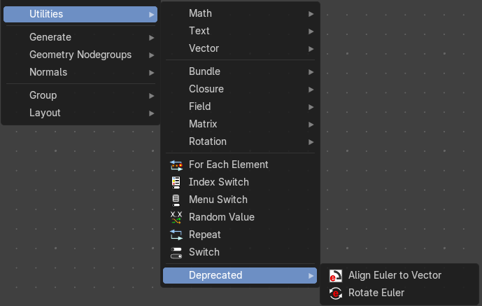
These deprecated nodes are kept for compatibility reasons.

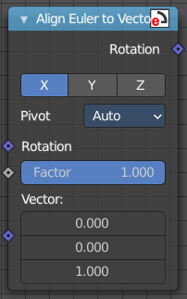
Align Euler to Vector (Deprecated)
Aligns a euler value to a vector.

Inputs

Rotation
The input euler rotation vector.

Factor
The factor to align the euler value to the vector.

Vector
The vector to align to.

Properties

Align Axis
To which axis to align the vector.

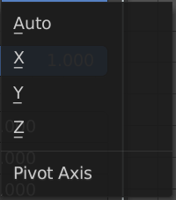
Pivot
The pivot axis.

Output

Rotation
The output rotation euler angle.

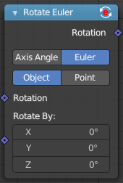
Rotate Euler (Deprecated)
Rotates an euler rotation. This node will be removed in the near future. Alternatively use the Rotate Rotation node.

Inputs

Rotation
Use the rotation of an existing geometry.

Rotate By
The input rotation.

Properties

Rotate Type

Axis Angle
Rotate around an axis by an angle.

Euler
Rotate around the x, y and z axis.

Rotate Space

Object
Rotate points in the local space of the object.

Point
Rotate every point in its local space.

Outputs

Rotation
The euler angle output.

